# *IT Club Internship – Week 5 Report*

***Student Name: Irfan Younas***

***Intern ID: ITCP-20445***

***Domain: Computer Networking***

***Week 5 Topic: Network Troubleshooting and Monitoring***

***Duration: 25th August – 31st August 2025***

## Objective

To develop troubleshooting and monitoring skills for network maintenance using Cisco Packet Tracer. This includes identifying connectivity issues, resolving IP conflicts, and configuring SNMP for real-time network monitoring and alerts.

## Task 1: Network Troubleshooting

### Scenario 1: IP Conflict

Problem: Two hosts within the same subnet were configured with identical IP addresses, causing intermittent network disconnections.

Symptom Observed: The system displayed the warning — “This IP address is already used in the network.”

Reason: Duplicate IP assignment within the same subnet.

Solution Implemented: Verified IP addresses using 'ipconfig', released and reassigned IP, ensured all devices have unique IPs.

Result: All hosts now communicate successfully without IP conflict.

### Scenario 2: Connectivity Issue

Problem: The IT department was unable to communicate with the Admin and Training departments.

Diagnosis: Ping tests failed between subnets. Checked router interface statuses using 'show ip interface brief'. Found FastEthernet 0/1 interface in administratively down state.

Root Cause: Router interface Fa0/1 was shut down.

Solution Implemented:

Router# configure terminal  
Router(config)# interface fastEthernet 0/1  
Router(config-if)# no shutdown  
Router(config-if)# exit  
Router(config)# end  
Router# write memory

Result: Interface restored to operational state. Successful pings confirmed full connectivity between all departments.

## Task 2: SNMP Configuration

Objective: To configure Simple Network Management Protocol (SNMP) on the router and enable network monitoring alerts.

Router> enable  
Router# configure terminal  
Router(config)# snmp-server community cisco123 RO  
Router(config)# snmp-server host 192.168.30.100 version 2c cisco123  
Router(config)# snmp-server enable traps  
Router(config)# snmp-server enable traps snmp linkdown linkup  
Router(config)# interface fastEthernet 0/1  
Router(config-if)# snmp trap link-status  
Router(config-if)# exit  
Router(config)# do write memory  
Router(config)# exit

Explanation:  
- snmp-server community cisco123 RO – Sets community string (read-only).  
- snmp-server host 192.168.30.100 version 2c cisco123 – Defines SNMP manager IP and version.  
- snmp-server enable traps – Enables SNMP trap notifications.  
- snmp trap link-status – Enables interface link-up/down trap reporting.

Result: The router successfully sends SNMP traps to the SNMP Manager Server. Network administrators can now monitor router status and receive alerts automatically.

## Results

## Task 1:

**Network topology :**

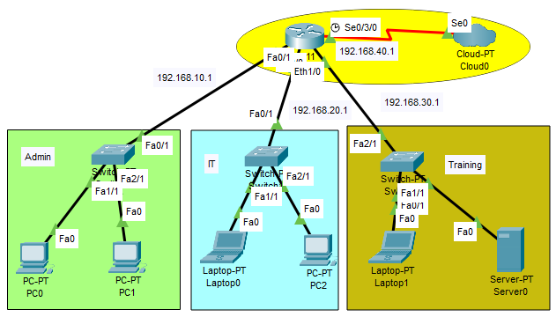

***Trouble shooting :***

***Scenario 1:***

***IP conflict:***

If ip address overlaps than the ip will not be assigned and the error shows “this ip address is already used in the network “:

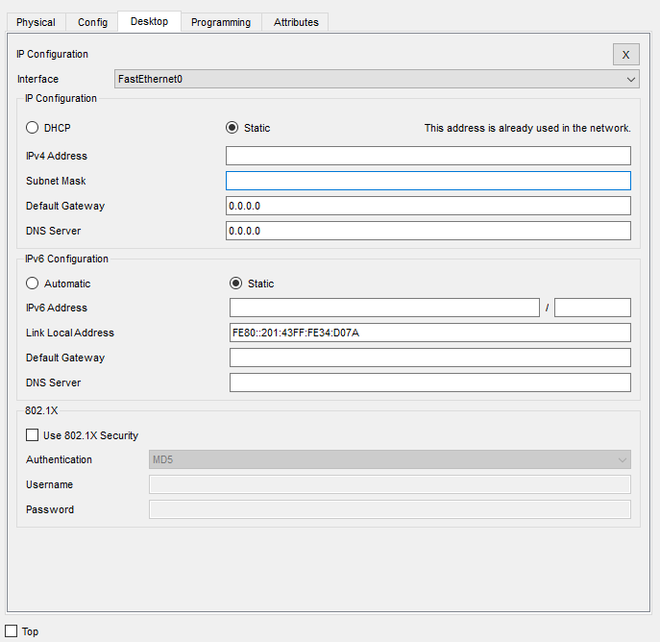

***Scenario 2:***

***Connectivity issues :***

The IT department is unable to communicate with admin and training department :

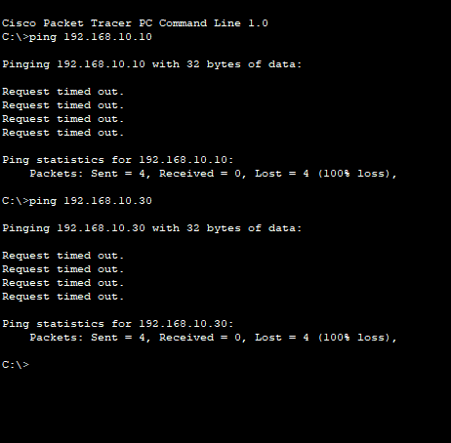

Reason : The interface fastethernet 0/1 is down

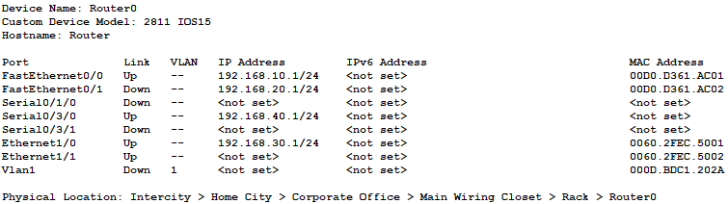

Solution:

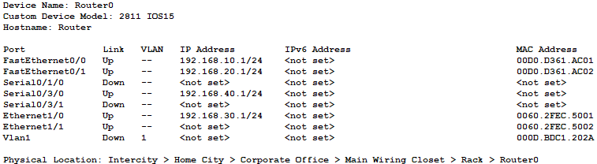

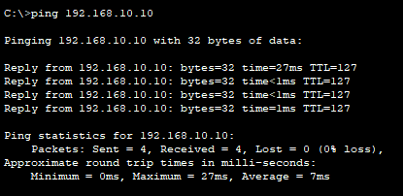

## Task 2:

SNMP configuration ;

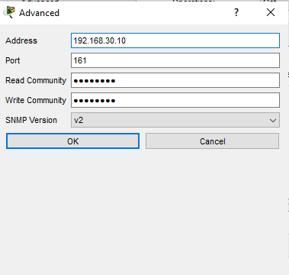

Result ;

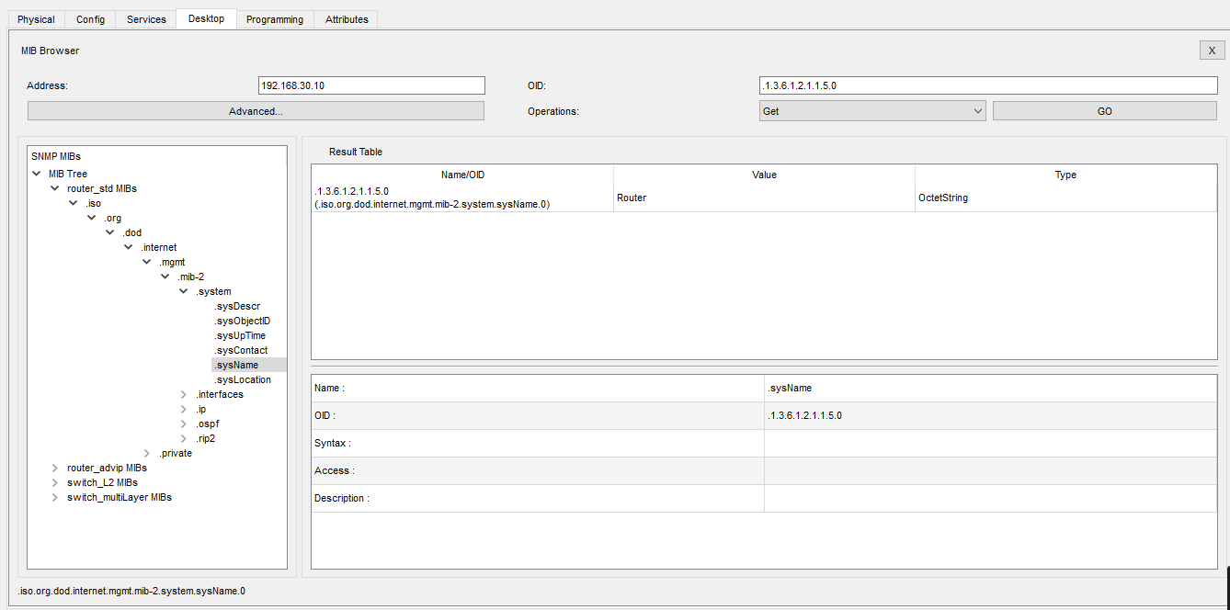

## Summary of Learning

Gained practical exposure to diagnosing and resolving network errors (IP conflict, interface down). Configured SNMP for proactive network monitoring and alerts. Strengthened understanding of Cisco router CLI and basic network maintenance workflow.

## Conclusion

Week 5 activities provided hands-on experience in identifying and resolving real-world network issues. The SNMP configuration enhanced visibility and monitoring efficiency across all departments. This week successfully developed essential troubleshooting and monitoring competencies required for professional network administration.